**Assignment -2**

|  |  |
| --- | --- |
| Assignment Date | 19 September 2022 |
| Student Name | Dhivanesh M.R |
| Student Roll Number | 111519106027 |
| Maximum Marks | 2 Marks |

**Question:**

Build a python code, assume you get temperature and humidity values(generated with random function to a variable) and write a condition to continuously detected alarm in case of high temperature .

**Solution:**

Code:

Import random

Temperature = random.randint(0,200)

humidity = random.randint(0,100)

print(“The recorded temperature in Fahrenheit= ”,temperature)

print(“The recorded humidity in percentage= ”,humidity)

if(temperature>110 or humidity>30):

print(“HIGH TEMPERATURE-Alarm ON”)

else:

print(“Alarm oFF”)

output:

CASE 1: ALRAM-OFF

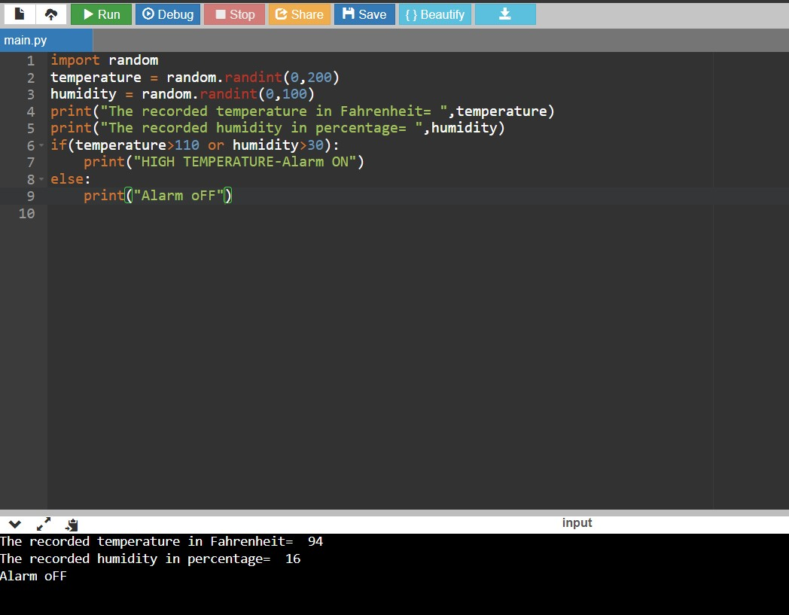

# CASE 2: ALRAM-ON

